Online Safety Newsletter

April 2024

Poppy Playtime

It is important that you are aware that whilst the name and characters suggest a playful game, it is a survival horror game with graphics that may not be suitable for your child. It includes characters such as 'Kissy Wissy' and 'Huggy Wuggy.' Please view this game before allowing your child to play it as it may not be appropriate for them – particularly young children.

Children may be playing the game or just watching videos of it on sites such as YouTube or playing replicated versions on Roblox for example.

Further information
Safer Schools NI have produced this informative:
https://saferschoolsni.co.uk/huggy-wuggy-online-safety-review/
Cyberbullying

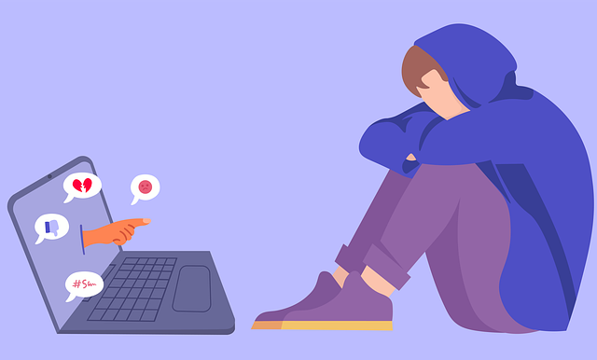
What is cyberbullying?
Cyberbullying is bullying online and can take many forms such as sending malicious messages, leaving nasty comments, excluding somebody from a group chat, blackmailing or setting up a fake profile. Cyberbullying can take place across many different platforms such as WhatsApp, Snapchat and on games such as Roblox and Minecraft.

What should I do if my child is being bullied online?
If your child is being bullied, then try to stay calm and let them know that it is not their fault. It is always useful to keep evidence of any online bullying and inform their school so that they are aware. Show your child how to block and/or report any users/content and review their privacy settings to limit what others can see. You may also wish to set up any parental controls that are available.

Further information
There is a vast amount of information available online about cyberbullying. The following links provide further information on types of online bullying, how to support somebody who is being bullied and who you can contact if you need any further advice or support.
Talking to strangers online

There are many apps/websites where your child may come across strangers contacting them. Some platforms will allow you to set who can contact your child as well as switch off communication so ensure appropriate settings are explored and set up. This article from ThinkUKnow talks about how to protect your child from adult content and contact:
https://www.thinkuknow.co.uk/parents/Concerned-about-your-child/Online-contact-and-staying-safe/

- https://www.childnet.com/help-and-advice/online-bullying/
- https://www.nationalbullyinghelpline.co.uk/cyberbullying.html
- https://www.youngminds.org.uk/young-person/coping-with-life/bullying/
Group Chats

Group Chats are available on various messaging apps, social media apps and in some games. When your child is part of these groups, they may not know all the other members and it may even include people that they have previously blocked. Your child may come across inappropriate content and bullying can take place within these groups. Talk to your child about how they speak to others online and encourage them to talk to people online with kindness, like they would if they were face-to-face. The NSPCC provide further information about group chats here:
https://www.nspcc.org.uk/keeping-children-safe/online-safety/social-media/chat-apps/

Users of this guide do so at their own discretion. No liability is entered into. Current as of the date released 01.04.24.

Online Challenges

Our children may not have developed the skills and ability to critically analyse all situations yet so it is important to talk to your child about hoaxes and challenges that may appear on the internet. Some challenges are fun and provide no risk, however there will be challenges that are risky/dangerous. Just recently, a child sadly died after participating in a challenge - more information here: https://ineqe.com/2024/03/19/dangerous-challenge-safeguarding-risks/

Your child may see others complete certain challenges online without being harmed and therefore may want to repeat them and not consider the potential risks to themselves. Make sure they know that they should talk to you (or another trusted adult) about what they see online, particularly if they plan to try a challenge.

We would always advise that if your child has not heard about an online challenge, then do not draw attention to it as this may lead to them searching for it out of curiosity, so just talk about challenges in a general sense. Furthermore, reassure your child that challenges that suggest that terrible things will happen if they do not complete the tasks are not real.

The following link will provide you with further information as well as content to help you talk to your child:
https://www.internetmatters.org/connecting-safely-online/advice-for-parents/tackling-the-hard-stuff-on-social-media-to-support-young-people/online-challenges-are-they-harmless/

TikTok have also produced this resource to help you talk to your child about challenges and the potential risks: https://www.tiktok.com/safety/en-sg/online-challenges/

TikTok
You must be over 13 years of age to use TikTok.

TikTok is a social media platform for sharing and watching short video clips. Some of the videos may not be appropriate for your child to view and there is also the risk of strangers contacting your child. If your child is using TikTok then make sure appropriate security/privacy settings are applied.

Account set up
As always, it is important that when setting up an account, your child enters their real date of birth as accounts are tailored by age e.g., direct Messaging is disabled for accounts aged 13-15. In addition, advertisements are tailored to their age. By default, accounts for people under 16 are set to private and we would recommend keeping it as this. This means your child must approve follower requests. You can read more about the other settings available, such as switching off comments and switching on restricted mode here: https://support.tiktok.com/en/account-and-privacy/account-privacy-settings.

Family Pairing
This allows you to link your own account to your child’s account. You can then set controls such as restricted mode. You can find out more here: https://www.tiktok.com/safety/en/guardians-guide/

Inappropriate content, themes and challenges on TikTok
Whilst against TikTok’s guidelines, explicit and inappropriate content can be found on this platform, for example nudity/sexual content and hate speech. We often see viral challenges on social media, some of which can be dangerous. If your child is using TikTok, chat to them regularly about what they are viewing.

Trends and Influencers
We often see trends on social media, for example a latest trend found is around skin care routines, which can lead to children purchasing products that are completely unsuitable/dangerous for their skin. You can find out more here: https://www.bark.us/blog/skin-care-tweens/. Influencers are people who have a large following on social media who through recommendations and promotions, influence the behavior or buying habits of others. The NSPCC discuss what we need to be aware of here: https://www.nspcc.org.uk/keeping-children-safe/online-safety/online-safety-blog/2023-05-16-the-influence-of-influencers/

Stranger contact
Talk to your child about who is following them online and ensure that they understand that people may not be who they say they are when online. It is important that children know not to share personal information.

Blocking and Reporting
Ensure your child knows how to use the safety features available to them, including how to report comments, direct messages and another user.

Further information
- https://parentzone.org.uk/article/tiktok

